Search test cases:

1. Posting: not in any document. So not able to apply validation.
2. ultiMAtEly:

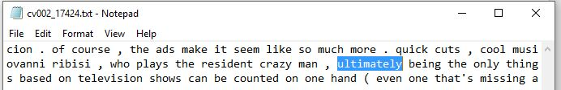

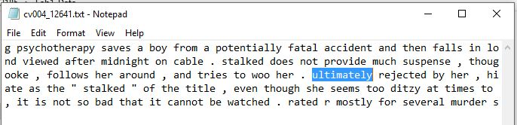

AND test cases:

1. minute AND character:

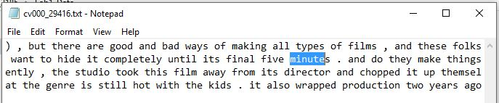

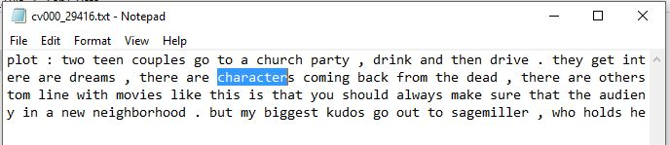

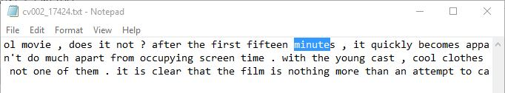

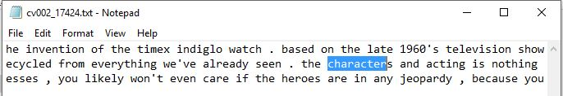

1. time AND fact:

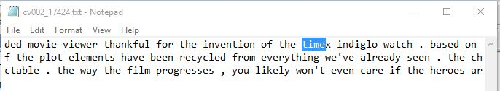

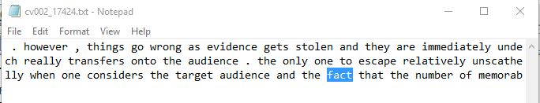

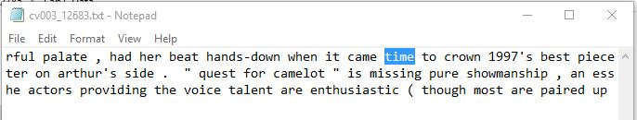

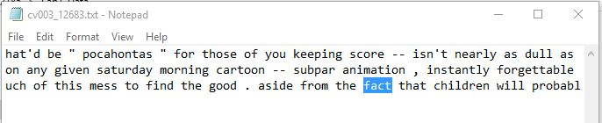

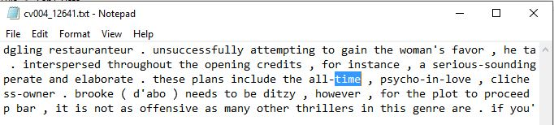

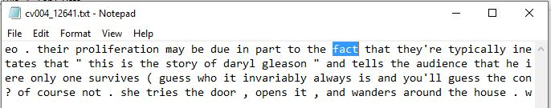

OR test cases:

1. cool OR danger:

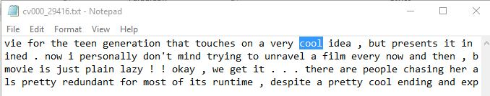

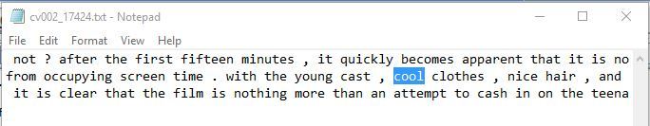

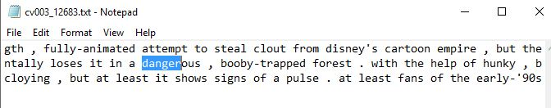

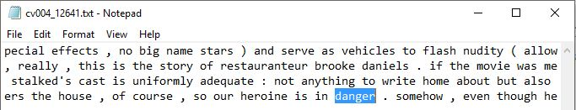

1. end OR border:

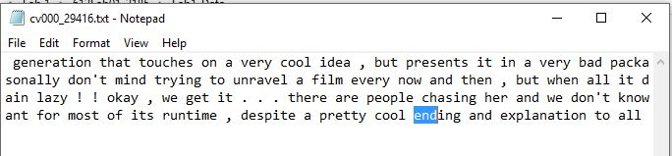

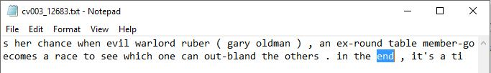

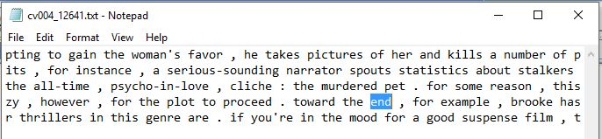

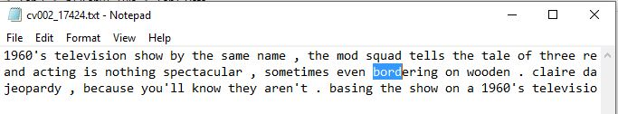

AND test cases (query words > 2):

1. chick owner ensures return

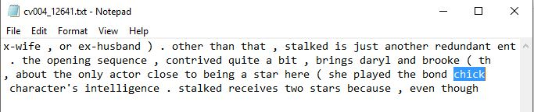

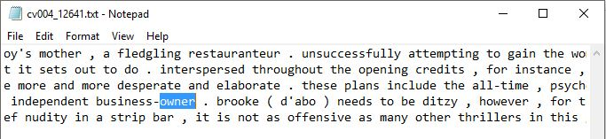

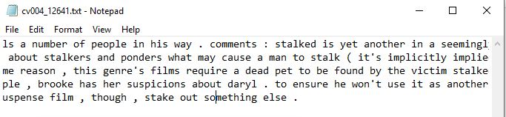

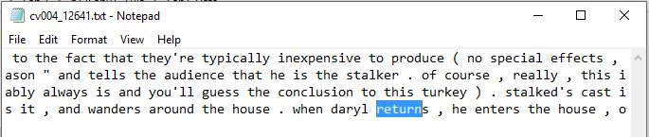

1. shoWing AMERIcan attempts:

